Assignment - 3
Module 3 – Introduction to OOPS Programming
- Introduction to C++
- What are the key differences between Procedural Programming and Object-Oriented Programming (OOP)?
- Here, below the difference :-

Procedure Oriented Programming | Object Oriented Programming
It is known as POP | It is known as OOP
It deals with algorithms | It deals with the data
Programs are divided into functions | Programs are divided into objects
Most of the functions share global data | Data structure characterizes objects.
It is top down approach | It is bottom up approach
It needs very less memory | It needs more memory than POP
It do not have any access specifiers. | It has access specifier like private, public and protected
It is less secure | It is more secure
Example :- C, FORTRAN | Example:- C++, JAVA, .NET, PYTHON

- List and explain the main advantages of OOP over POP.
- There are below the advantages of pop
- Advantages of OOP :-
- Encapsulation
- Polymorphism
- Inheritance
- Abstraction
- Easy Debugging
- Modularity
- Code Reusability
- Better security
- Explain the steps involved in setting up a C++ development environment.
- There are few steps involved in C++ development environment
- Install a C++ Compiler :-
Install a GCC, MinGW or Visual Studio (for windows).
The compiler converts the C++ code into a program.

- Install an IDE or Code Editor :-
Use visual studio, code blocks, dev C++ or VS Code to write code easily.

- Write a C++ Program :-
Create a file like main.cpp and write your code.

- Compile the program

- Run the program

- What are the main input/output operations in C++? Provide examples.
- There are few main input/output operations
- Output Operation (cout) :-
It is used to display the output on the screen.
It used to insertion operator <<
Example :-
#include<iostream>
Using namespace std;
Int main()
{
Cout<<”Hello World”;
Return 0;
}

- Input Operation (cin) :-
it is used to take input from the user
it is used to extraction operator
Example:-
#include<iostream>
Using namespace std;
Int main()
{
Int age;
Cin>>age;
Cout<<”Age is = ”<<age;
Return 0;
}

- Error Output :- (cerr)
it is used to display a error message.
Output is unbuffered (shown Immediately)
Example :-
cerr << "Error occurred!";

- Log Output :- (clog)
It is used for logging message.
Output is buffered.
Example :-
Clog <<”This is a log message”;

- What are the different data types available in C++? Explain with examples.
- Basically, there are four types of data types.
- Primitive Data types
- Derived Data types
- User-defined data types
- Modified Data types

- Primitive Data types :- These are the fundamental datatypes built into C++.

Data Type | Description | Example Declaration | Example Usage
Int | Stores whole number | Int a = 10; | Cout<<a;
Float | Stores Decimal Values(single precision) | Float x = 5.5; | Cout<<x;
Double | Stores Decimal Values(double precision) | Double x = 10.2345; | Cout<<x;
char | Stores a Single Character | Char ch = ‘Y’; | Cout<<ch;
Bool | Stores a true or false Value | Bool flag = true; | Cout<<flag;
void | Represents No Value | Void display(); | Used in function with no return value

- Derived Data Types :-

Data Type | Description | Example Declaration | Example Usage
Array | Collection of same type elements | Int arr[3] = {1,2,3}; | Cout<<arr[0];
Pointer | Stores address of variable | Int* ptr = &a; | Cout<<*ptr;
Reference | Alias for variable | Int& ref = a; | Cout<<ref;
Function | Block of code with return type | Int add(int x, int y); | Cout<<(2,3);

- User-defined Data types :-

Data Type | Description | Example declaration | Example usage
Struct | Group different data types | Struct student{  Int age; } | Student s1; s1.age = 20;
Class | Blueprints for objects | Class car {public : int speed; } | Car c; c.speed = 100;
Union | Share same memory for different variables | Union data {int a; float b; } | Data d; d.a=5;
enum | Name constants | Enum day {Mon,Tue}; | Day d = Mon;
Typedef/using | Creates type alias | Typedef int Marks; | Marks m = 90;

- Modified data types :-

Data type | Description | Example declaration | Example Usage
Signed | Allows positive & negative values | Signed int a = -20; | Cout<<a;
Unsigned | Only allows positive values | Unsigned int b = 20; | Cout<<b;
Short | Smaller range integer | Short int x = 100; | Cout<<x;
long | Larger range integer | Long int y = 1000000; | Cout<<y;
Long long | Very large integer | Long long int z = 1234567890; | Cout<<z;

- Example :-

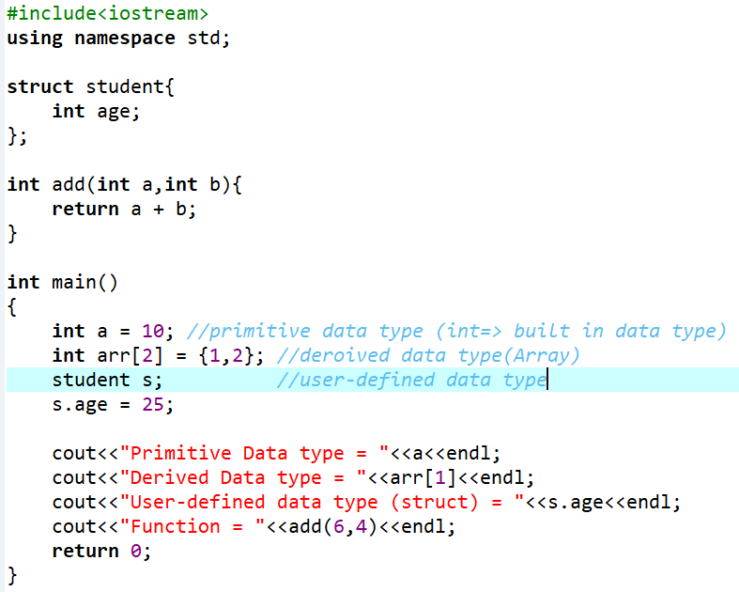
Output:-
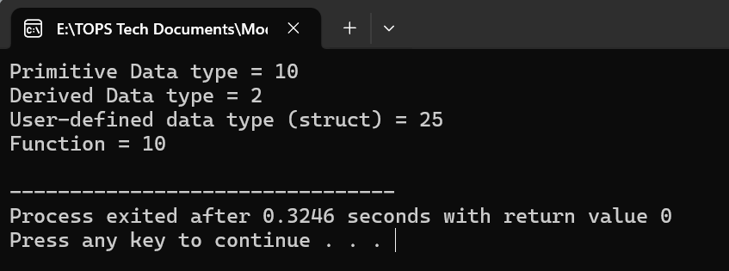
- Explain the difference between implicit and explicit type conversion in C++.
- There are few differences below :-

Implicit Type Conversion | Explicit Type Conversion
Type conversion is that which automatically converts the one data type to another | Type conversion is that which manually converts the one data type to another
Implemented only when two data types are compatible | Implemented only when two data types are incompatible
No Operator Required | Operator Required
It is done explicitly while compiling | It is done during program designing
It is a widening conversion | It is a narrowing conversion
Example :-  Int a = 5, double b = a; → a is automatically converted to double | Example :-  double a = 5.7; int b = (int)a; → programmer forces conversion.

- What are the different types of operators in C++? Provide examples of each.
- There are different types of operators below:-
- Arithmetic Operator :-
Operator | Name | Description | Example
+ | Addition | Add Two Operands. | 5 + 2 = 7
- | Subtraction | Subtract right operands from left | 5 – 2 = 3
* | Multiplication | Multiplies by Two Operands | 5 * 2 = 10
/ | Division | Divides left operands from right | 5 / 2 = 2.5
% | Modules | Return the reminder of an integer division | 5 % 2 = 0.1

- Relational Operator :-
Operator | Name | Description | Example
== | Equal to | Check if two operands are equal. | 5 == 2 evaluates to 0 (false)
!= | Not Equal to | Check if two operands are not equal | 5 == 2 evaluates to 0 (false)
< | Less than | Checks if left operand is less than right | 5 < 2 evaluates to 0 (false)
> | Greater than | Checks if left operand is greater than right | 5 > 2 evaluates to 1 (true)
<= | Less than or Equal to | Checks if left operand is less than or equal to | 5 <= 2 evaluates to 0 (false)
>= | Greater than or Equal to | Checks if left operand is greater than or equal to | 5 >= 2 evaluates to 1 (true)

- Logical Operator :-
Operator | Name | Description | Example
&& | Logical AND | Return 1 if both the conditions are true. | (5 > 2) && (2 < 5) evaluates to 1
|| | Logical OR | If one condition are true than true otherwise false | Logical OR
! | Logical NOT | Reverses the logical state of an operand | (5 == 2) evaluates to 1

- Assignment Operator :-
Operator | Name | Description | Example | Equivalent to
= | Assignment | Assign the value on right to the variable on the left | a = 5 | a = 5
+= | Add and Assign | Adds right operand to the left operand and assigns the result to the left. | a+=2 | a = a + 2
-= | Subtract and Assign | Subtracts right operand from the left operand and assigns the result to the left. | a-=2 | a = a - 2
*= | Multiply and Assign | Multiplies right operand with the left operand and assigns the result to the left. | a*=2 | a = a * 2
/= | Divide and Assign | Divides left operand by the right operand and assigns the result to the left. | a/=2 | a = a / 2
%= | Modules and Assign | Takes modulus using two operands and assigns the result to the left operand. | a%=2 | a = a % 2

- Increment/Decrement Operators :-
Operator | Name | Description | Example
++ | Increment | Increases the integer value by one. | ++a (prefix) or a++ (postfix)
-- | Decrement | Decrement the integer value by one. | --a (prefix) or a-- (postfix)

- Bitwise Operator :-
Operator | Name | Description
& | Bitwise AND | Sets each bit to 1 if both bits are 1.
| | Bitwise OR | Sets each bit to 1 if either of the bits is 1.
^ | Bitwise XOR | Sets each bit to 1 if only one of the bits is 1.
~ | Bitwise Complement | Inverts all the bits of the operand.
<< | Left shift | Shifts the bits of the left operand to the left by the number of positions specified by the right operand.
>> | Right shift | Shifts the bits of the left operand to the right by the number of positions specified by the right operand.

- Conditional Operators :-
Operator | Name | Syntax | Description | Example
?: | Conditional | condition ? expression1 : expression2 | If the condition is true (1), expression1 is executed; otherwise, expression2 is executed. | Result = (marks >=60)? ‘pass’ : ‘fail’

Example :-
Input:-
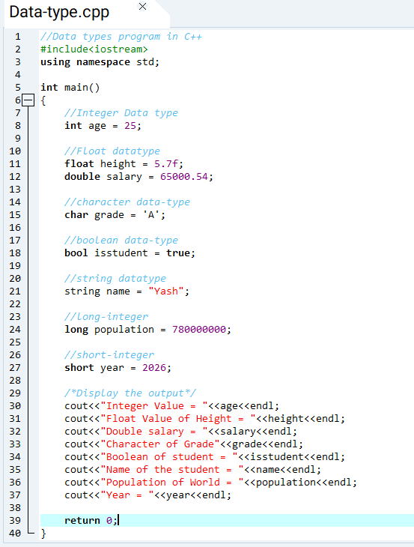
Output:-
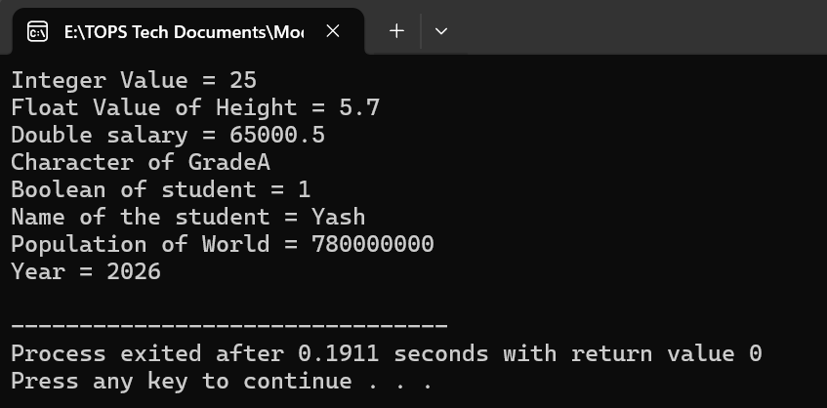
- Explain the purpose and use of constants and literals in C++.
- Constant in C++ :- constant is a variable whose value cannot be changed once it is defined. It is declared using const keyword.
Purpose of Constants :-
- To store a fixed values that should not be changed during program execution.
- To improve code readability.
- To prevent accidental modification of important data.
- To make program easier to maintain.
Example :-
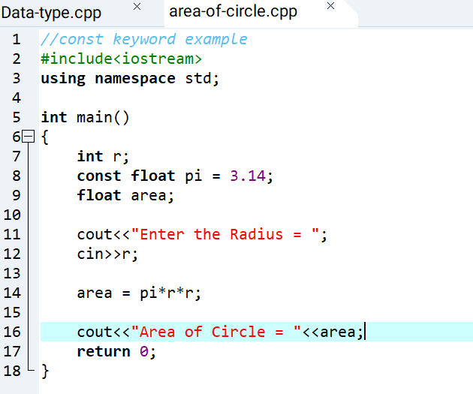
Output:-
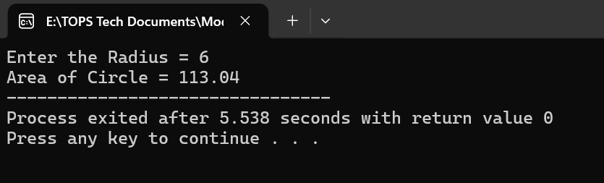
- Literals in C++ :- A literal is a fixed value written directly in the program. It does not change during execution.
Purpose of Literals :-
- To represent fixed value directly in code.
- Used to assign values a variable.
- Used in expression and calculation.
Types of Literals :-
- Integer – literal
- Floating – literal
- Character-literal
- String-literal
- Boolean – literal
Example :-
Int age = 25;
Float pi = 3.14;
Char cha = ‘A’;
- What are conditional statements in C++? Explain the if-else and switch statements.
- Conditional statement are used to control the flow of program based on certain condition.
- They allow the program to make decisions and execute a different blocks of code depending on whether a condition is true or false.

- If-else Statement :-
- Executes one block if the condition is true.
- Executes another block if the condition is false.
- Example :-
If(age>=18){
cout <<“Eligible for voting”;
}else{
Cout<<“Not Eligible for voting”;
}
- Switch statement :-
- Used when there are multiple fixed choices for a single variable.
- Use Case, break and default.
- Example :-
Switch(day){
Case 1:
Cout<<“Monday”;
Break;
Case 2:
Cout<<“Tuesday”;
Break;
Default:
Cout<<“Invalid Day”;
Break;
}
- What is the difference between for, while, and do-while loops in C++?
- Here’s the below the basic difference :-
Feature | While loop | For loop | Do While loop
Condition Check | Checked before each iteration | Checked before each iteration | Checked after each iteration
Minimum Execution | 0 times | 0 times | At least one time
Loop Structure | Condition only | Initialization, Condition and Modification | Body-first and Condition Last
Risk of infinite loop | Medium | Low | Medium
Typical Syntax Style | While(condition) | For(Initialization; condition; modification) | Do { } while(condition)

- How are break and continue statements used in loops? Provide examples.
- Here’s below the explanation.
- Break Statement :-
- Used to terminate a loop or switch statement immediately.
- Control goes to the statement after the loop or switch.
- Where to used :- for, while, do..while and switch.
- Example :-
Input:-
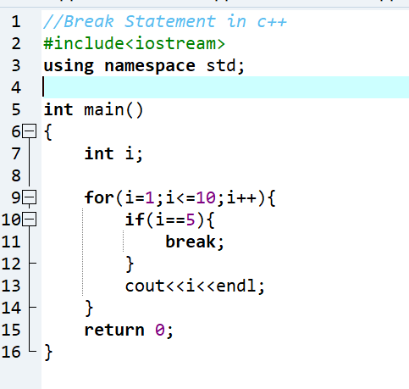
Output:-
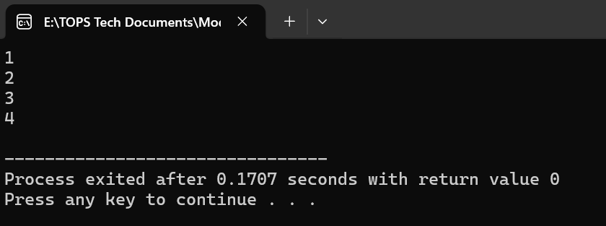
- Continue Statement :-
- Used to skip current iteration of loop.
- Loop continues with the next iteration.
- Where to used :- for, while, do..while and switch.
- Example :-
Input:-
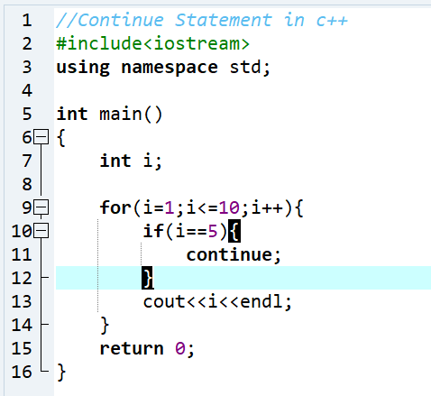
Output:-
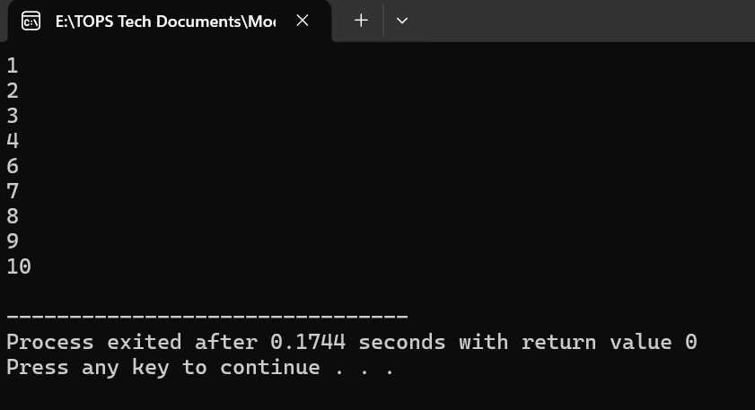
- Explain nested control structures with an example.
- A nested control structure occurs when a control statement such as , if, if-else, for, while or switch is written inside another control statement .
- Purpose :-
- Check Multiple conditions
- Handle complex-decision making.
- Control program flow more precisely.
Example :-
Input:-
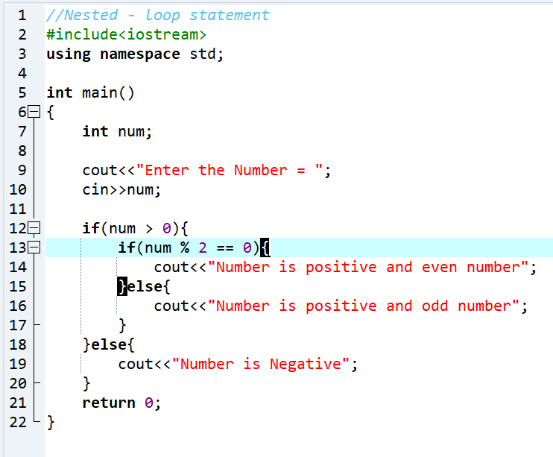
Output:-
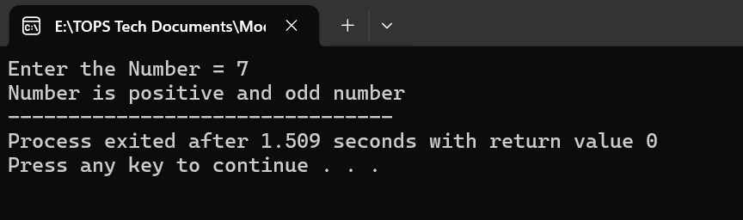

- What is a function in C++? Explain the concept of function declaration, definition, and calling.
- A functions is a block of code that perform a specific tasks.
- It helps divide the big problems into smaller parts.
- Every C++ program has at least one function – main().
- Function Declaration :-
- Tells the compiler the function is exist.
- Specifies
- Return type
- Function name
- Parameters written before main()
Syntax :- return type function_name(p1,p2,p3);
Example:- int add(int,int);
- Function Definition :-
- Contain actual code of the function.
- Written after main() or before it.
Syntax :-
Return type function_name(parameters){
//code
}
Example :-
Int add(int a, int b){
Return a + b;
}
- Function call :-
- Used to execute the function
- Can be called from main() or another function
Syntax:-
Function_name(arguments);
Example:-
Sum = Add(10,20);
Program Example :-
Input:-
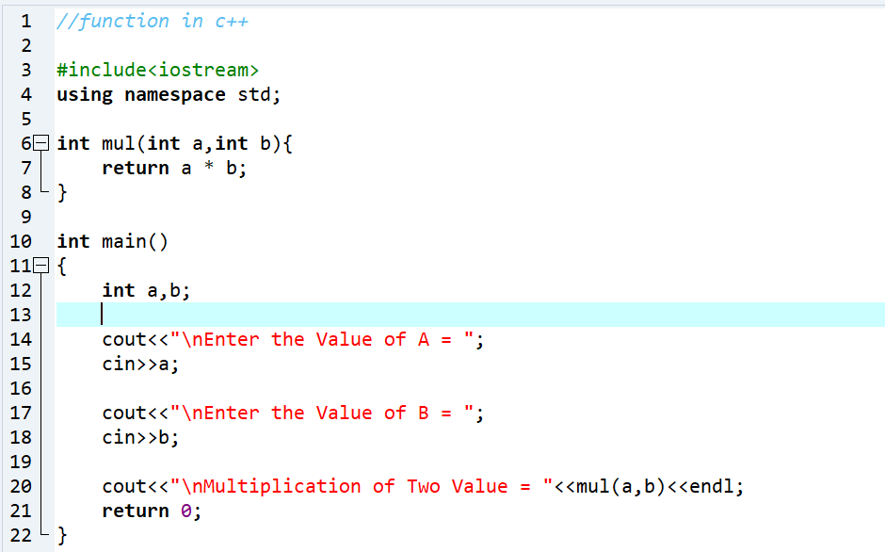
Output :-

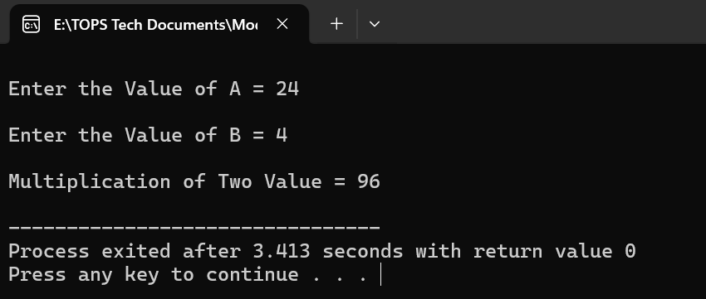

- What is the scope of variables in C++? Differentiate between local and global scope.
- Scope is a part of the program where a defined variable can have it’s existence and beyond that it cannot exist that is know as scope.
There are below basic difference :-

Local Variable Scope | Global Variable Scope
Local variable are declared inside the function. | Global variable are declared before the main function.
Local variable cannot be accessed outside the function | Global variable can be accessed in any function.
Local variable are alive only for a function | Global variable are alive till the end of the program.
More reliable and secure since other functions cannot change the value. | Accessible by multiple functions, therefore it’s value can be changed.
- Explain recursion in C++ with an example.
- Recursion :-
Recursion is when a function call it’s self to solve a problem.
It breaks big problems into smaller.

There are two types of recursion.
Base class :- stops the recursion
Recursive call :- the function call it’s self.

Example :-
Input:-
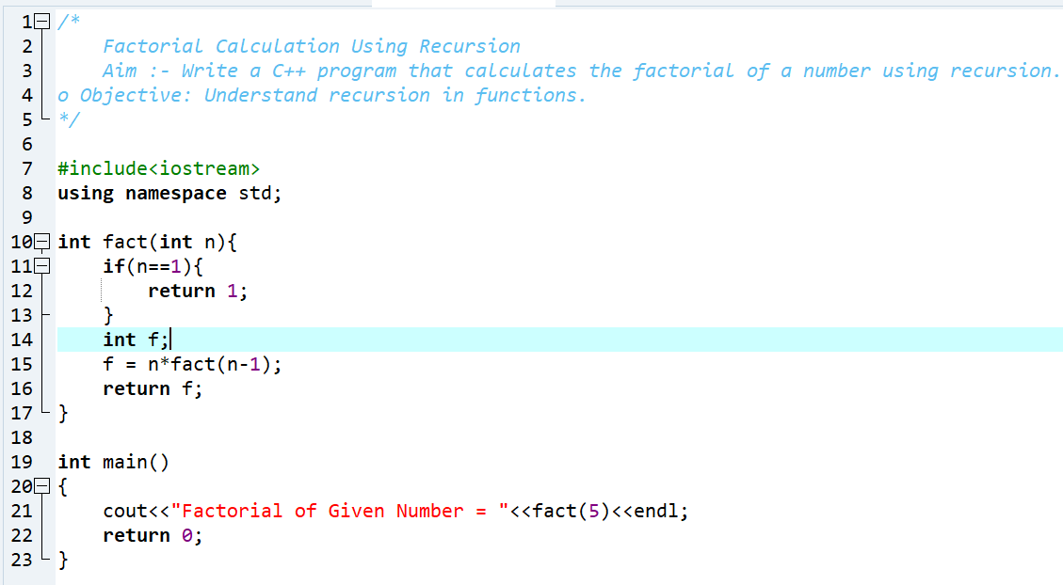
Output:-

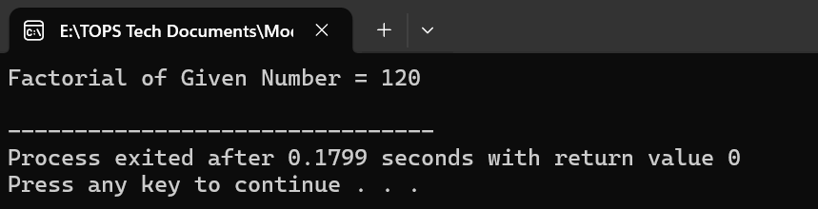

- What are function prototypes in C++? Why are they used?
- Function prototype is a function declaration that tells the compiler about the function name, return type and parameter before it is used.

Syntax :- return type function_name(parameter);

Example :-
Input:-
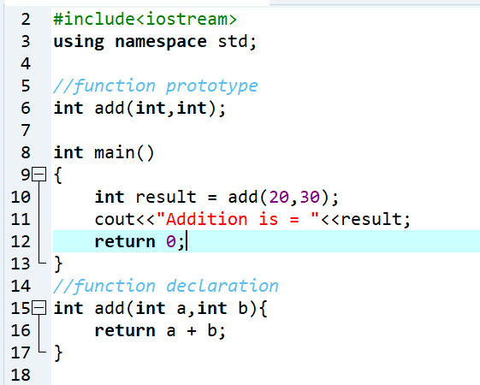
Output:-
